Matthew Trinh

4/14/2024

Assignment 5.2

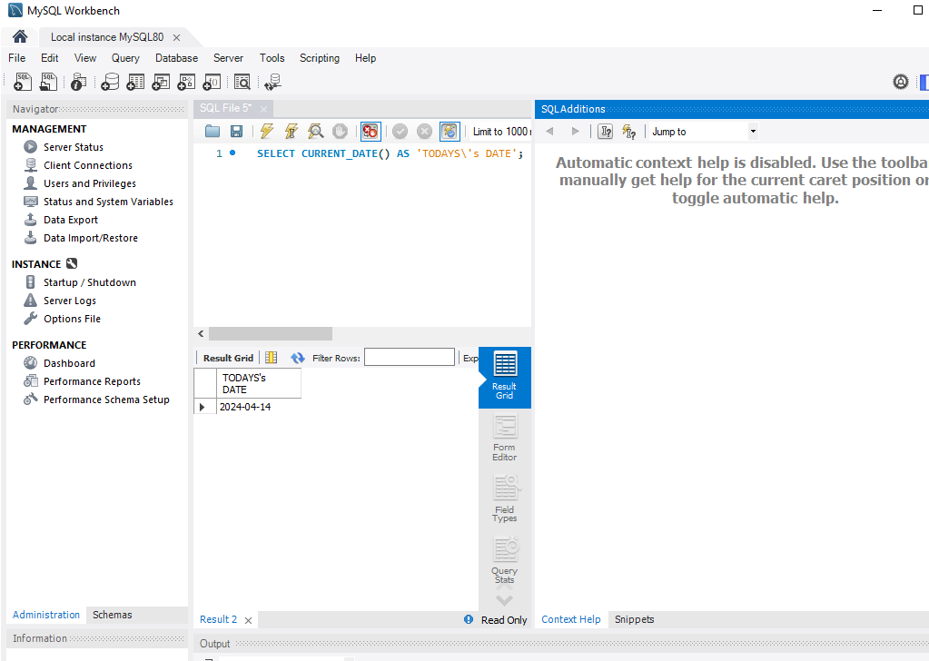

With MySQL alias is made to pull specific data within a database. Say for example I would like to look up user ID and username I can display all that information. Say I’m a teacher and I must input their grades, but in the system to input their grades it only shows their school id numbers. To which pulling up their information would make the teachers life a lot easier.

